***GENERAL ENGLISH PRE-INTERMEDIATE IMPLEMENTATION:* LEARNING RESOURCES FOR LOCAL AND INTERNATIONAL STUDENTS**

Yuyun Ilantri1, Ahmad Bukhori Muslim2, Isti Siti Saleha Gandana3

*Universitas Pendidikan Indonesia, Indonesia*

Corresponding Email: [YuyunIlantri@upi.edu](mailto:YuyunIlantri@upi.edu)

**Abstract**

The aim of this study is to identify the learning resources that are employed in a language center at Indonesia's oldest university for both domestic and foreign students. As the researcher utilizes content analysis to examine the many kinds of learning resources employed, this research approach is descriptive. Regarding the information gathered from a team leader with knowledge in leading the General English team. The results of this study revealed that although this school already uses quite full teaching materials, numerous evaluations still need to be done, particularly with regard to textbooks that are deemed to be out of date. The primary instructional materials that serve as a teacher's guide have evolved from textbooks. Additionally, this module makes use of digital learning resources including well-known websites. Additionally, a yearly revised curriculum, slideshows, and instructional materials created by the teachers all promote learning.

**Keywords:** *General English, learning resources, local and international students*

**Introduction**

Learning tools that promote learning can dramatically increase learners' achievement (Brown, 1995; Brown, 2001; Brown, 2007; Tomlinson, 1995). Grossman (1990) adds that teachers must choose relevant themes and be aware of their students' prior knowledge and beliefs in order to provide appropriate and compelling representations of the content to be acquired. According to Cunningsworth (1995), teachers can create learning materials that include enjoyable text and enjoyable exercises for pupils. Teaching and learning materials can also give structure to lesson planning and instruction delivery. Both the teacher and the learner can use learning resources as a guide. Teaching and learning materials can also give structure to lesson planning and instruction delivery. Both the teacher and the learner can use learning resources as a guide. They can be an important routine in the teaching and learning process (Brown, 2007; Harmer, 2001; Tomlinson 1995). Brown (1995) concludes that a resource can be highly beneficial for teachers in assisting pupils to acquire English. According to Harmer (2001), teaching materials are any items that will be utilized to assist instructors and teachers in carrying out teaching and learning activities in the classroom. It is suggested that teachers could provide several forms of learning tools (Brown, 2001; Harmer, 2001).

In line with the importance of a teacher's role in creating teaching materials in class (Brown, 1995; Brown, 2001; Brown, 2007; Tomlinson, 1995), teachers will be expected to be creative in their use of learning resources in class, as they must create interesting text and enjoyable activities for the students (Tomlinson, 1995). According to Brown (2001), a course book is best understood as a resource for achieving goals and objectives that were previously defined in terms of learners' needs. Furthermore, the textbook should be supplemented with useful resources that teachers can use to complement their education (Linse, 2005). For example, an instructive movie may bring new insights to a learner, while an appealing worksheet may provide new opportunities to practice a new skill learned in class. According to Harmer (2001), students' knowledge is influenced not just by what is spoken, but also by what they see, hear, and, most importantly, touch and interact with. According to Brown (2001), textbooks are the most popular type of teaching material in language classes.

Jassim and Jassim (2021) argue that analyzing materials is crucial since it shows whether particular teaching pedagogies are appropriate. Besides, the study tries to investigate learning resources utilized by teachers for both local and international students in implementing *General English Pre-Intermediate*. As the evaluation of the textbook is also part of this study, it will lead to the process of collecting and assessing data to make judgments lead to improve decision (Jahangard, 2007). Moreover, this study will present the evaluation and implementation of the textbook in order to measure how well a book is (Tomlinson, 2011).

In 2016, Rosyida conducted a study titled "Teachers Perception toward the Use of English Textbooks." A qualitative study is used to gather data and understand it. The case study examines a number of issues, one of which is the challenges involved in selecting, analyzing, organizing, comprehending, and integrating English textbooks. She discovers that professors have a key role in applying the course book throughout the lesson. It is suggested that teachers make thoughtful decisions and make sure the resources used closely reflect the curriculum and the needs of the pupils. The teachers also assert that they use additional worksheets to give their students more diverse exercises. She believes that teachers should have the freedom to develop extra materials and change or adjust the elements in the textbook in order to assist learning, advance students' knowledge, and motivate them, even if students are generally satisfied with the textbooks they choose. Also, assert that they use additional worksheets to give their students more diverse exercises.

Next, Handayani (2021) conducted a thesis titled The Evaluation of English Textbook Interactive English 1 for Seventh Grade of Junior High School Published by Yudhistira. This qualitative research found that textbook covers most of the sub aspects of content. She adds that the teachers who will utilize a textbook should provide authentic and current materials for additional learning resources and arrange more activities that will stimulate the students thinking skills. Moreover, Septiana et al. (2020) found that teachers have positive attitudes towards the use of Super Minds textbook. Besides, they are able to present the materials well and could implement it with relevant learning resources. Somehow, they believe that teachers have to prepare the teaching and assessment activities well. Hence, Learning resources are crucial to the learning process because having access to sufficient learning resources will aid teachers and students in aiding the learning process and achieving the established learning objective. Moreover, Jassim and Jassim (2021) conducted a paper entitled evaluating English for Iraq textbook grade 5 in terms of textbook quality standards. The study was conducted to compare between the pupils book and activity book of American Council for Teaching of Foreign language (ACTFL) standards. The data was gathered statistically through questionnaire with the English The data of Unit 8 was analyzed descriptively. It is discovered that the English book already meet the standard of ACTFL for communication, cultures, connections, comparisons, and communities. Also, it meets the 5 match cultures and connections standards largely whereas it matches communications, comparisons, and communities moderately.

Therefore, before beginning to teach, a teacher must first do all of the necessary planning. In general, teachers' success in the classroom is largely dictated by the preparedness of their lesson plans. When something is carefully planned, the end product will be good. Teaching materials are one of the things that a teacher must prepare before carrying out learning in class. Because instructional materials contribute significantly to the success of learning implementation. Teaching materials organized in this manner, in accordance with existing provisions and systematics, will be extremely beneficial to teachers and students during the teaching and learning process. Moreover, learning evaluation is critical for determining the effectiveness of a learning system adopted by educators. Because failing to do an evaluation means that an instructor has made no progress in building a learning system. Besides, students naturally want to hear something new every day(Kearney, 2013). In other words, the teacher's evaluation seeks to determine whether or not students have mastered the information being taught. Furthermore, whether or not the teaching activities carried out are in conformity with what is expected.

**Theoritical Framework**

***Learning Resources***

Learning resources will refer to any person(s) or any material (whether acquired or locally produced) with instructional content or function that is used for formal or informal teaching/learning process (Tomlinson, 1995). Also, as a teacher, we can also adapt the materials that can be reducing, adding, omitting, modifying, and supplementing (Tomlinson, 2011). Therefore, Ball et al. (2008) claims that the content of teaching must be related and understandable to the key feature of the materials. In same line, Grossman (1990) adds that teachers must select appropriate topics and their knowledge of students’ prior knowledge and conceptions to formulate appropriate and provocative representations of the content to be learned. Kumaravadivelo (2006) the teachers are also able to create learning resources for the student such as dialogue in order to increase their creativity in improve their writing and speaking skills. Wu (2023) teachers lead the beginning process and end of the teaching process and play important role in the teaching process. Hence, Grossman (1990) concludes that the teachers are required to beyond know knowing the content. To conclude, the learning process must be supported by learning resources in order to create more appropriate language teaching and learning atmosphere.

***The importance of Learning Resources***

Brown (1995) concludes that a resource can be highly beneficial for teachers in assisting pupils to acquire English. According to Harmer (2001), teaching materials are any items that will be utilized to assist instructors and teachers in carrying out teaching and learning activities in the classroom. Tomlinson (2011) adds learning resources are beneficial to help language learners to learn. It is suggested that teachers could provide several forms of learning tools (Brown, 2001; Harmer, 2001). Teacher must know the subject they teach that will stimulate the students thinking skills, the learning resources are required in the both types of the class (Handayani, 2021) as it is beneficial to affect the success or failure of language learning. Also, teachers should also pay closer attention to each component of the lesson plan, such as the gadgets, online platforms, internet connection, and online resources (Al Farid & Damayanti, 2022).

Kumaravadivelo (2006) argues that developing activities that integrate listening, speaking, reading, and writing skills. Moreover, Linse (2005) claims that various learning resources will help students improve their writing skills. Teacher needs to provide vocabulary exercises to increase students’ mastery regarding new vocabularies (Alqahtani, 2015). Reading materials on the textbook are able to engage students’ attention because the topics are really “full of knowledge” (Rynanta & Ruslan, 2013). In hence, learning resources play fundamental role in language learning to increase all of skills in English including speaking, listening, writing, and reading.

***Text-based learning resources***

The course book may include an explanation and an exercise that we find useful almost every time (Harmer, 2007). It is also the most common form of teaching material in language classes (Brown, 2001). Also, O’niel (1982) presented that textbook is a visible heart of any English program of the language input learners that they receive in the classroom. Teachers may use various types of worksheets to increase students' understanding by implementing such an easy activity for both teachers and students (Harmer, 2001). Moreover, textbook can act as a reference point for their learning process and keep their development (O'niel, 1982). Moreover, Handayani (2021) believes that the teachers who should utilize a textbook should provide authentic and current materials for additional learning resources and arrange more activities. A textbook's attractive design or layout, both on the cover and within the book is one of the requirements for a good book (Pasaribu, 2022). To conclude, textbook is defined as the main guidance of teaching and learning activities as it plays fundamental role in the English language input.

***Digital learning resources***

Kearney (2013) believes that technology can you increase student involvement in your classroom, and in so doing energizing and empowering your students to learn. Learning resources may include, but are not limited to, print and non-print; audio, visual, electronic, and digital hardware/software resources; and human resources (Harmer, 2001) a cassette, CD-ROM, a video (Tomlinson, 2012). Kearney (2013) technology can you increase student involvement in your classroom, and in so doing energizing and empowering your students to learn. It is believed that all lessons delivered via the internet, which is defined as a complex and rapidly expanding network or network of interconnected computer networks (Rennie & Smyth, 2020). New technologies: internet, emails, Youtube, chatrooms, blogs, video conferencing and mobile phone technology (Tomlinson, 2012). It might downloadable and printable worksheet from any kind of websites. Linse (2005) believes that web resources such as newspaper, films, documentaries, soap operas and others might be learning resources. This type learning resources has been very helpful lately especially during COVID-19 (Al Farid & Damayanti, 2022).

***Other learning resources***

As it is also necessary for supplementing a textbook (O’niel, 1982), any other type of learning resources would be beneficial during the lesson. Furthermore, according to Harmer (2001) and Linse (2005), pictures or visuals play important roles in developing young learners' linguistic skills and assisting students in better grasping the lesson. Teachers should also pay closer attention to each component of the lesson plan, such as the gadgets, online platforms, internet connection, and online resources (Al Farid & Damayanti, 2022). Moreover, teachers may use various types of worksheets to increase students' understanding by implementing such an easy activity for both teachers and students (Harmer, 2001). Harmer (2001) stated that teachers can make the lesson more interesting by using flashcards, sample cards, and a drawing board. (Linse, 2005) She goes on to say that magazines and newspapers can be used in the classroom to help students improve their writing skills. Moreover, photocopied handout, novel, article, and a newspaper would work in the class (Tomlinson, 2011, 2012). Also, use essay as close-ended tasks and exercise where the learner determines what to say and how to say it. Despite there are various types of other learning resources, the teachers are still required to use relatable learning resources for the students (Harmer, 2007)

***Textbook: General English-Pre Intermediate***

General English (GE) program is designed by language center at one of Universities in Bandung, Indonesia. It aims to fulfill the need of those who want to learn and improve their communication skills in English, both spoken and written, in the day to day context. The program is designed with communicative and interactive learning concept to provide participants with interesting and stimulating activities to practice and use the language meaningfully. The program is offered in five levels (elementary, pre-intermediate, intermediate, upper-intermediate, and pre-advanced), each of which last for 8 sessions of 100 minutes each (4800 minutes or 80 learning hours total). In this study, the researcher will be focused on two classes of pre-intermediate level. These classes are under two different teachers that assist each other both local and international student. Each class will have 10 maximum numbers of students. The classes are held on Tuesday and Wednesday start at 16.40 until 18.00 WIB. The textbook is published by the university publisher but the teachers are able to develop any other learning resources to use in the class as Brown (2007) notes that teachers have a crucial role in developing and using materials.

**Methodology**

***Research design, site, and participants***

Research design used comparative study approach as the methodology, interview, and documentation as the instrument that conducted in one of private primary schools. This study was conducted at one of Indonesia's oldest university language centers. The program is designed with a communicative and interactive learning concept in mind to provide participants with engaging and stimulating experiences. The writer purposefully chose individuals and locations to learn about or understand the primary phenomenon, just as the researcher utilized purposeful samplings (Cresswell, 2012; Licthman, 2006). Besides, the checklist adapted from Sheldon (1982) is conducted to investigate more information. Thus, in this data analysis based on Johnson and Christensen (2008), the writer made a detailed description of the fundamental structure of the informant experience. This process was essential so that they were meaningful and interrelated to each other among categories or themes. It is concluded that descriptive qualitative data is a technique that necessitates the writer's comprehension of the material through data collection and analysis (Cresswell, 2012; Merriam, 2009).

**Finding and Discussion**

***Textbook***

Based on the data, the researcher discovered that a book produced by their own institutions serves as the primary handbook in the General English class. Their primary teaching tool is a textbook. Additionally, it is the most typical type of teaching aid used in language schools (Brown, 2001). The teachers simply need to teach the subject in this book because it has been used for a long time in this institution.

*“….we have one module which is hmmm for levels, there are five levels at GE, at our institution, yeah. The first is elementary, there is pre-intermediate, then there is upper intermediate, and the last one is pre-advance and each level has its own module which has been written by one of our instructors as well as staff at our institution and has on the ISBN right. So this is already a book that we made, hmmmm what is it, so this book has become a book. And every level, even every program has a different book….”*

Also revealed is that the team coordinator said that this book has been used in this institution for a very long time. Additionally, they offer books for every level, so there is never a shortage of textbooks. It was also written and implemented for the Pre-Intermediate level of the General English course book.

***Figure 1.*** textbook for General English

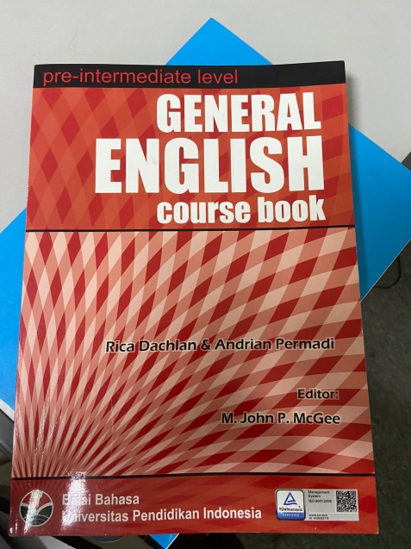

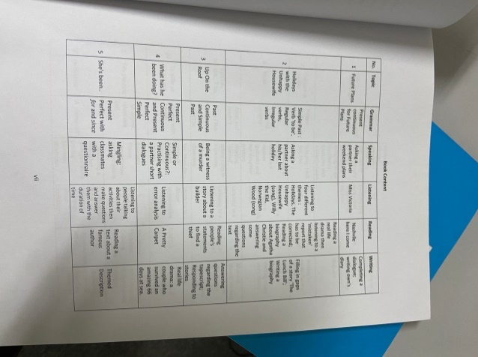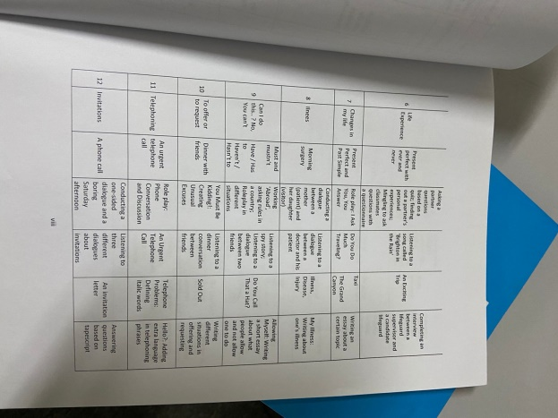

This book displays clear and has decent paper quality. Also, this book has given readers enough useful information that it is simple to locate sub-chapters on each page. A total of 12 chapters in this book, and they will be covered in 21 meetings. This book's educational goals have also been met. The coordination team claimed that the book was not visually appealing, so it only included language and images in black and white, which made the book less engaging. While, one prerequisite for a good book is that the textbook has a visually appealing design or layout, both on the cover and inside the book (Pasaribu, 2022). The textbook, according to O'Niel (1982), is the clear center of any English program and the primary source of language instruction for students in the classroom.

***Table 1.*** Textbook factual details by Sheldon 1982

|  |  |  |
| --- | --- | --- |
| Title : Pre-Intermediate level: General English course book | | |
| Authors : Rica Dahlan & Andrian Permadi | | |
| Publisher : Balai Bahasa Universitas Pendidiakan Indonesia | Price : Included in class’s price | |
| ISBN :978-602-97459-4-8 | No. of Pages :165 | |
| Components : SB/TB/Tests/Cassettes/Video/CALL/Other : none | | |
| Level : Pre-intermediate | | Physical size : 30x25 cm |
| Length : 30 cm Units : 2 Lesson/Section : 24 Hours : 1 hour & 40 mins (100 mins) | | |
| Target skills : Speaking, Listening, Writing, Reading, and Grammar | | |
| Target learners : 18-50 years old | | |
| Target teachers : experienced English teachers | | |

This book, which Rica Dahlan and Andrian Permadi wrote in 2011, has served as the primary teaching resource ever since. This book will come with every student, ages 18 to 50, who enrolls in the Pre-Intermediate course. The book contains 165 pages and has a recognized ISBN. Speaking, listening, reading, and grammar are all included as learning objectives in this comprehensive book. This book is simple to use according to the straightforward writing style, nice fonts, and headings. This book is a reasonable size, making it simple to pack in a backpack. Each participant in this program must attend 24 sessions totaling 100 minutes each. However, this book is not equipped with cassettes/video/audio or other supported learning resources.

“*…to implement books for each level because at one level there are 24 meetings minus 3 progress tests so for effective learning there are 21, that means yes. So every 7 meetings, the 8th meeting is a progress test. The teacher is welcome to see, map the learning of the KBM for 21-24 meetings…”*

According to the findings, each level of the book must be implemented considering there are 24 sessions each level, less 3 progress tests, meaning that 21 meetings are necessary for optimal learning. A progress test is therefore held after every seven meetings. The teacher is invited to map the KBM's learning over the course of 21–24 meetings. As a result, they have a variety of teaching arrangements, such as having one teacher teach a single class, team teaching, or having one teacher meet with the class once before having a second teacher teach it the following day. Therefore, one or two teachers must assess the syllabus and the book's suitability.

Furthermore, each instructor has her unique approach to utilize this book in the classroom as well. It's only that this institution has guidelines for using this book in class as well.

*“…so for them, we have various teaching arrangements, for example there is one class taught by one teacher or it could be team teaching or one teacher meets the class one time the next day by another teacher…”*

The coordinator used to pair up the teachers in order for them to use the book in class. As a result, they have a variety of teaching arrangements, such as having one teacher teach a single class, team teaching, or having one teacher meet with the class once before having a second teacher teach it the following day. Therefore, one or two teachers must evaluate the syllabus and the book's suitability.

*“…and they are allowed to modify, not modify books, but modify teaching materials. Yes, they are even required to send out a lesson plan, complete with the lesson plan later whether they have the latest handouts…”*

Every instructor must also exercise creativity when utilizing their resources. Because even though they may have used the same book and taught from it multiple times, there may have been updates that included new handouts, slides, or other materials. As a result, they now have references for what to teach and what resources the material comes from. In light of this, the book is simply meant to serve as a general guide for teachers, ensuring that every class works toward the same objectives while utilizing flexible teaching strategies and resources. So that the activities are all different later in class and later in practice.

*“…the difficulty, for example, is this, this book took quite a long time from when I first entered it, and it was already available around 2014/2015, that's how it is. So, sometimes, there are teenager who are general English, right, so this class is opened from high school, maybe high school students now don't know some content or some stories…”*

She noted that several people, particularly high school students, believed that this book was irrelevant. This book's material is rather dated considering that it was written in 2011. According to Handayani (2021), teachers who use textbooks should set up extra exercises and provide authentic, up-to-date materials as supplemental learning tools. Somehow, the humor in this book might not be age-appropriate, current, or relevant, therefore the instructor is free to choose another text to use in class as long as it has the same objective, language focus, or overall topic.

***Figure 3.*** Text example in the book ***Figure 4.*** Text example in the book

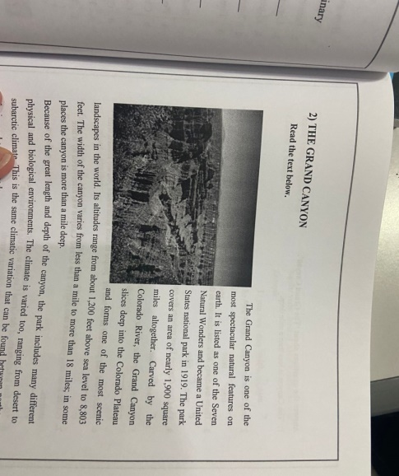

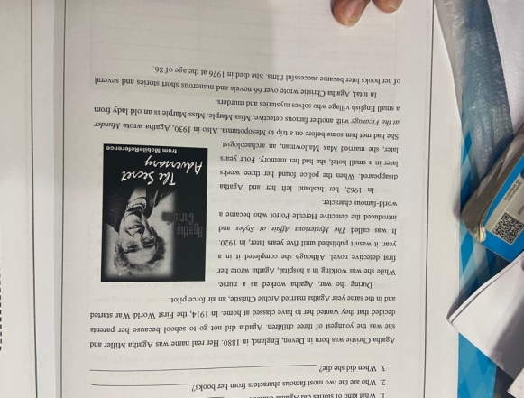

The two images above there show the variety of discourse they are having. ***Figure 3*** depicts a historical individual who was well-known. While ***Figure 4*** describes a well-known tourist destination in the US. However, this presents a special challenge for teachers when students between the ages of 18 and 25 are unfamiliar with the figures in picture 3. The instructor will have to explain and it will take time for the children to come to know her if this reading material is employed. Due to the themes' true "full of knowledge" nature, reading materials from the textbook are able to hold students' interest (Rynanta & Ruslan, 2013). It will be simpler for students to recognize and discuss recent texts if the teacher uses them as teaching materials.

Additionally, the study discovered that both local and international students received the identical instructional materials.

*“Then, there are fresh graduates but they are foreigners, men, yes, from Tajikistan, then there are also those from Timor Leste whose women are currently taking their Masters , and the others are undergraduate and graduate students. So we use the same teaching materials for them”*

She added that in her most recent class, which had about 10 pre-intermediate pupils, there were 24 meetings held twice a week for one level. Thus, the course will be completed in three months. Three of the initial 10 students were male, while the remaining eight were female. Registration began with high school, and we had two high school students—one in grade 10 and one in grade 11, if I'm not mistaken. Because it will encourage them to speak English in class, using the same teaching materials for both domestic and foreign students will increase the success of learning English.

***Digital learning resources***

It is undoubtedly encouraging to increase their digital literacy as a source or a learning tool in the classroom in this all-digital world. Digital literacy is equally crucial for the teachers in this institution. Consequently, the following instructional resources are digital ones that teachers use in the classroom.

*“…usually, there are resources that we get from the internet, there are websites that, for example, are often taken and opened. British council learning English… apart from that, we also have e-books with examples like this, like reading* extra, maybe you already know. Listening extra, there are lots of e-book lists.”

Today's digital age, however, encourages teachers to use a wider variety of educational resources. This institution also goes through it. He claimed that they frequently used teaching resources from the *British Council* to bolster listening instruction for kids. Also utilized to help learning are Reading Extra and Listening Extra. Slides that are frequently distributed to students also frequently use images from Google.

**Figure** 5. Reading Extra

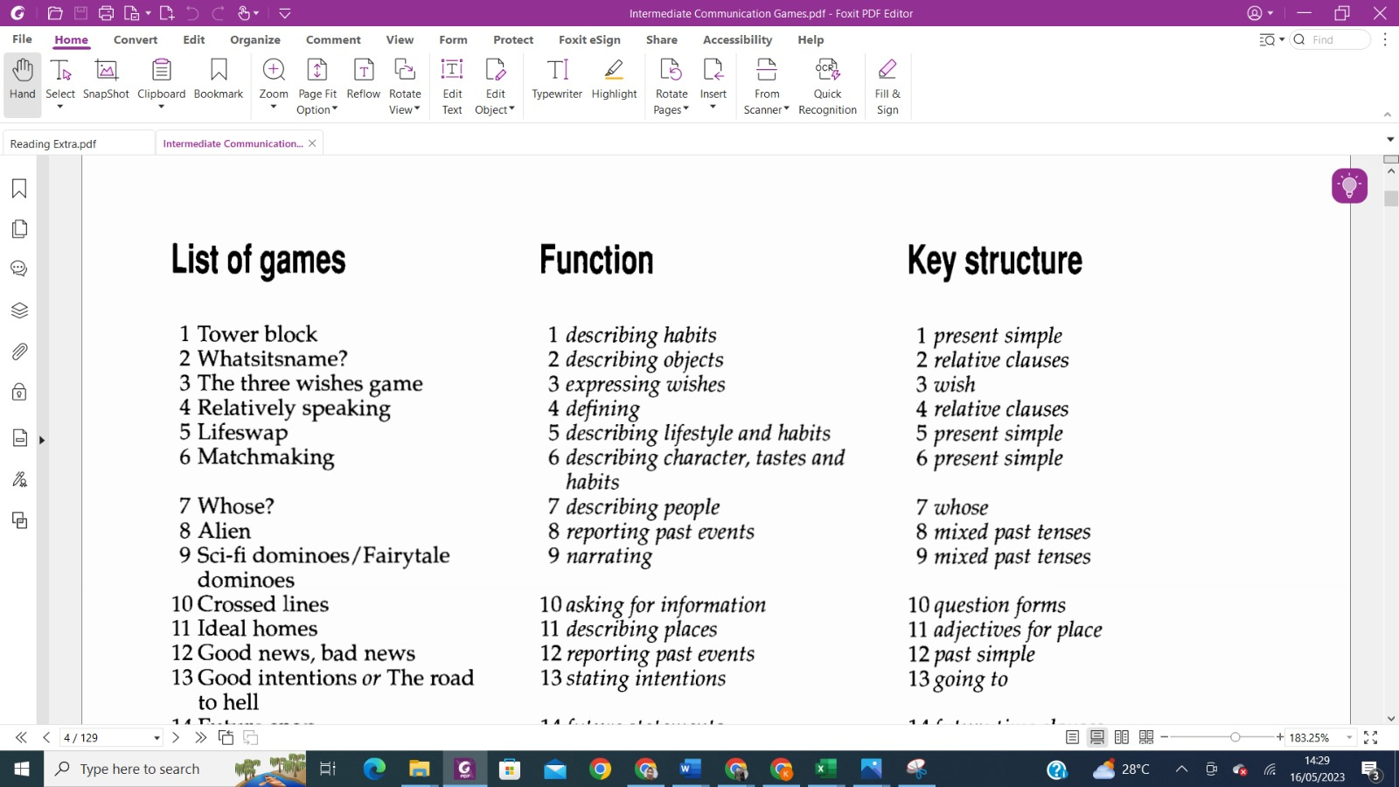

They have used the teaching resource *Reading Extra* as supplemental course material. This instructional material comprises of numerous reading genres that can be used to teach grammar, writing, speaking, and reading. This instructional material is available to each teacher through their coordinator team. Based on the General English book, which serves as the primary teaching resource in the class, each of the teaching resources it contains can be customized to the needs of the individual student. Due to the variety of reading assignments and the detailed lesson plans, this teaching material is fairly comprehensive. Additionally, instructional resources for games will be provided to the teacher, making learning much more fun.

Additionally, this kind of instructional material will not be used at every meeting but rather in accordance with the guidelines in the General English textbook. If reading or listening and learning go hand in hand, Reading Extra or the British Council will provide an additional reading. In order for teachers to adapt the educational materials they employ to the needs of their students. Teachers can also substitute teaching resources from Reading Extra, the British Council, or other sources for those that are thought to be inappropriate for young students.

*“…from us is the general English one. Therefore, I prefer to use the 100 minutes to chat or something, or at a meeting or in the early minutes, let's see the book. I see what page the book is on, what the topic is, what language focus we are discussing. However, usually they don't use books anymore…”*

Students who want to practice speaking English should take this module. Although the textbook has all the necessary skills, the team coordinator instructs the instructor to concentrate on improving the pupils' English speaking abilities. As a result, they encourage students to speak up a lot in class because they are exposed to a lot of English during those 100 minutes, and the instructor may utilize this as an opportunity to improve the students' speaking abilities.

A cassette, CD-ROM, or video (Tomlinson, 2012) are examples of learning resources that can include, but are not limited to, print and non-print; audio, visual, electronic, and digital hardware/software resources; and human resources. On the other side, Berge & Clark (2005) claimed that if we overly rely on technological resources, pupils' motivation levels may drop. In order to prevent a decline in the enthusiasm of class activities, teachers should ensure that the volume of digital learning resources is still manageable and distributed appropriately.

Additionally, this institution initially promoted digital learning by giving computers to each instructor so they could submit lesson plans. Every teacher that instructs here will have access to uploaded teaching resources. It's only that the computer isn't currently provided, so teachers must pick it up from the coordinator team. If other teachers wish to use it, they can get in touch with the coordinator team. It is also claimed that teaching reading can occasionally result in boredom if all students do is read texts, therefore teachers occasionally have trouble coming up with reading-related learning activities.

Moreover, this institution initially supported digital learning by providing computers that each teacher could use to upload teaching materials. Uploaded teaching materials will be accessible to every teacher who teaches here. It's just that, at this time the computer is no longer provided so teachers can only collect it from the coordinator team and if other teachers want to access it, they can contact the coordinator team. It is also stated that learning reading can sometimes lead to boredom if only reading texts, so sometimes teachers face difficulties in creating learning activities in reading skills. Technology, according to Kearney (2013), can boost student engagement in the classroom, motivating and empowering your pupils to learn. However, he also cautioned against using too much technology in the classroom because it may reduce pupils' ability to think passively, which will influence how well they remember the material. Therefore, the amount of technology used in the classroom needs to be optimal in order to aid students in developing their comprehension.

***Other learning resources***

Obviously, the teacher employs various types of teaching materials in addition to textbooks and online learning resources to complete the module's teaching materials. It certainly makes teachers aware of supporting learning activities with various types of digital teaching materialsThis is anticipated to facilitate more varied learning with the aid of additional instructional resources created by the university and the academic staff.

*“…so every year at our place we make or renew the syllabus that we have. So in this syllabus, at this level, what makes it is the teaching team and the English language coordinator here, usually they already have it so what is the material…”*

***Figure 6.***Syllabus

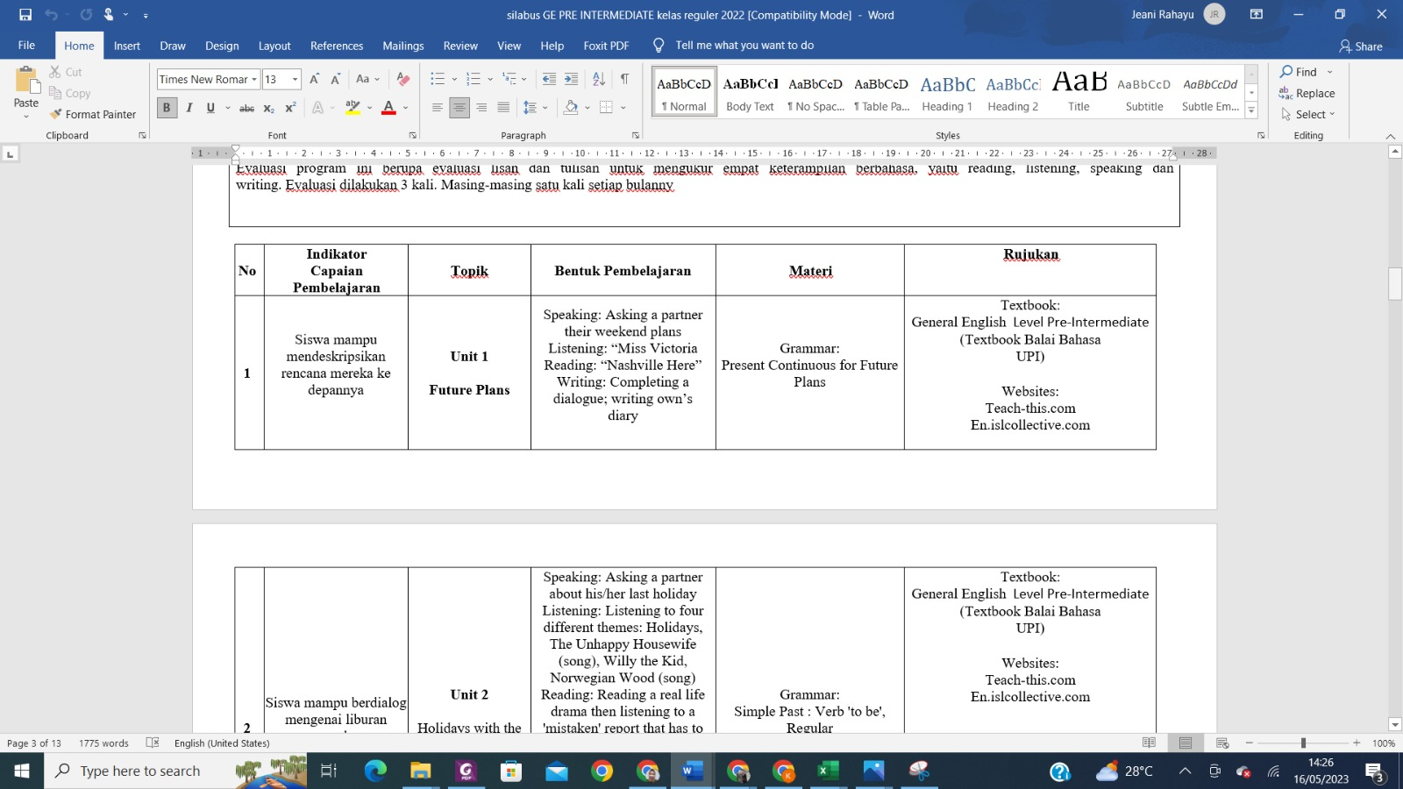

The teacher can then add to this each year, making the textbook the primary resource for the first year. For the following year, they are free to add additional material or even grammar. Then there are websites that we frequently use to retrieve resources, activities, handouts, or other exercises. These are created every year, and they evaluate them once more every year, but since it is the end of 2022, we will update our evaluation later this year to reflect how it will be in 2023 and 2024. Later, the teacher will add it if something new or an easier-to-use, more recent website becomes available. Finding numerous routes to the same destination in order to teach to mastery allows for everyone to fully absorb the lesson (Kearney, 2013). Therefore, even while the coordinator might give the instructors a template for the module, the teachers will still be able to decide how to best present the contents to the students based on the curriculum and the references.

According to Harmer (2001), teachers can make the lecture more engaging by utilizing a drawing board, example cards, and flashcards. However, this university does not frequently use board games or flashcards as teaching aids. Teachers frequently revise and alter textbook-based teaching materials. so that instructors become accustomed to creating presentations that may be distributed to students. In addition, because instructional materials are based on books, a lot of them are spoken activities that provide students a lot of speaking practice. Any additional learning resources would be helpful throughout the session because they are also required for supplementing textbooks (O'niel, 1982). (Linse, 2005) She continues by stating that newspapers and magazines can be used in the classroom to assist pupils in developing their writing abilities.

In conclusion, this institution has supplied quality teaching resources that are complimented by various extra teaching materials, according to the results of my research. The teachers supply teaching resources that are always current and may be changed each year, which makes it unique even if this book is rather old and not relevant to today's young people. The desire for new information among students is natural (Kearney, 2013). Additionally, Ryegard (2010) mentioned that it is crucial for all teachers to comprehend the demands and preferences of their pupils in the classroom. He contests the idea that students dislike it when teachers spend the majority of the class period lecturing. Additionally, according to Ball et al. (2008), the educational material must be relevant to and understood in light of the main aspect of the resources. Teachers must be able to manage the learning processes involved in establishing and sustaining the ideal conditions for interaction to occur and be processed, according to Djamarah (2005). They also give teachers the freedom to construct and alter lesson plans using books that are already on the market. This demonstrates that changing instructional resources to complement classroom activities will always be a part of the teacher's job description.

**Conclusion and Recommendation**

The descriptive study that is presented here can assist in identifying the learning resources that the institution uses. The objectives of each lesson were felt to have been met by the teaching resources employed. The primary book served as the primary guide, followed by the use of digital learning and various supplemental teaching resources. Just that the institutional coordination team is hoping for an upgrade to the textbook they now use. As a result, there are a lot of things that are inappropriate, such as the themes' lack of sequential order. Correction: That's how things are in this book. Although there have been many advancements, we haven't yet published any of them as books. Instead, they have been provided to students, for instance, in the form of teacher-given slides or handouts. This inspires educators to be more inventive when changing the resources they utilize for instruction. Consequently, the teachers could alter the teaching aids by, for instance, introducing board games, worksheets, or speaking activities (Brown, 2001).

Even if the coordinator noted that the book is not physically appealing, the content and text occasionally don't apply to this younger generation. As a result, this book is already properly arranged in terms of the skills and resources. The researcher believes that the institution will use this information to further expand and modify its learning resources and maybe issue an updated book shortly.

**Acknowledgements**

We would like to appreciate the participants of this research and our university, Universitas Pendidikan Indonesia. We would like to thank our family members who always support us.

.

**References**

Al Farid, A. A. P & Damayanti, I. L. (2022). The implementation of School from home in english for young learners classrooms. *Jurnal Pendidikan Indonesia, 22*(2), 1-16. DOI: <https://doi.org/10.17509/jpp.v22i2.49062>.

Ball, D. L., Thames, M. H., & Phelps, G. (2008). Content knowledge for teaching: what makes it special? *Journal of Teacher Education, 59*(5), 389-407. DOI 10.1177/22487108324554

Brown, H. D. (2001). *Teaching by principles.* An Interactive Approach to Language Pedagogy. Englewood Cliffs: Prentice Hall.

Brown, H. Douglas. 2007. *Principles of language learning and teaching*. USA: Longman

Brown, J. D. (1995). *The* *elements of language curriculum: A systematic approach to program design*. Boston: Heinle & Heinle.

Cohen, L., Manion, L., & Morrison, K. (2018). *Research methods in education* (8th ed.). London: Routledge. <https://doi.org/10.4324/9781315456539>

Creswell, J. W. (2012). *Educational research: Planning, conducting, and evaluating quantitative and qualitative research* (4th ed.). Boston, MA: Pearson.

Cunningsworth, A. (1995). *Choosing your coursebook*. Oxford: Heineman.

Djamarah, S. B. (2015). *Teachers and learners in educational interaction psychological a theoretical appro*ach. Rineka Reserved. Jakarta.

Grossman, P. L. (1990). *The making of a teacher: Teacher knowledge and teacher education*. New York: Teachers College Press

Grossman, P. L. (1990). *The making of a teacher: Teacher knowledge and teacher education*. New York: Teachers College Press.

Grossman, P. L. (1990). *The making of a teacher: Teacher knowledge and teacher education*. New York: Teachers College Press.

Handayani, N. (2021). *The evaluation of English textbook interactive English for 1 for seventh grade of junior high school*. Yudhistira

Harmer, J. (2007). *The practice of English language teaching.* Malaysia: Pearson Education Limited

Jahangard, A. (2007). The evaluation of the EFL materials taught at Iranian public high schools. *Asian EFL Journal, 9*(2), 1-122.

Jassim, H. H., & Jassim, R. R. (2021). Evaluating English for Iraq textbook grade 5 in termsof textbook quality standards. *International journal of humanities and educational research, 3* (4), 148-158. <http://dx.doi.org/10.47832/2757-5403.4-3.14>

Johnson, R.B. and Christensen, L.B. (2008). *Educational Research: Quantitative, Qualitative, and Mixed Approaches.* 3rd Edition, Sage Publications, Inc., Lose Angeles.

Kearney, E. M. (2013). *On becoming a teacher*. The Netherlands. Sense Publisher

Kumaravadivelo, B. (2006). *Understanding language teaching.* London: Lawrance Erlbaum associates, Publishers

Linse, C. T. (2005). *Practical English language teaching*: Young learners: New York: McGraw-Hill Companies Inc.

Litchman (2006). *Qualitative research in education: A user’s guide*. London Sage Publication

Merriam. S. B. (2009*). Qualitative research: A guide to design and implementation*. San Fransisco, CA Jossey-Bass.

Miles, M. B., Huberman, A. M., & Saldana, J. (2014). *Qualitative Data Analysis: A Methods Sourcebook, Edition 3.* USA: Sage Publications.

Miles, M.B, Huberman, A.M, & Saldana, J. (2014). *Qualitative data analysis, a methods sourcebook, edition 3*. USA: Sage Publications.

O'niel. R. (1982). Why use textbook? *ELT Journal, 36*(2).

Pasaribu, A. N. (2022). The EFL stdudents perceptions of the quality of the English language textbook. *English Review: Journal of English Education, 10*(2), 409-420. <https://doi.org/10.25134/erjee.vl0i2.6242>

Rennie, F., & Smyth, K. (2020). *Digital learning: The key concepts, second edition.* New York.

Rosyida, E. (2016). Teachers perception towards the use of English textbook*. Open Journal System UIN*, 9 (1), 43-54.

Rynanta, R. A. C., & Ruslan, S. (2017). Content analysis on the English textbook entitled “English in mind starter (Student’s book)”

Septiana, E., Mujiyanto, J., & Sutopo, D. (2020). Teachers perception, plan, implementation, and evaluation toward the use of Super Minds textbook in EFL classroom. *English Education Journal, 10*(3), 321-330.

Sheldon, L. E (1988). Evaluating ELT Textbooks and materials. *ELT Journal, 43*(4).

Spratt, M., Pulverness, A., & Williams, M. (2005). *The TKT (Teaching Knowledge Test) course.* Cambridge: Cambridge University Press.

Tomlinson, B. (1998). *Material development in language teaching*. New York: Cambridge University Press.

Tomlinson, B. (2011). *Materials development*. In Carter, R., & Nunan, D. The Cambridge Guide to teaching English to speakers of other languages. Cambridge: Cambridge University Press.

Tomlinson, B. (2012). *Materials development in language teaching 2nd edit*ion. Cambridge University Press.

Wu, M. (2023). Analysis of English teaching in Jinzhou City- take Yixian High School as an example. SHS Web of Conference, 168. <https://doi.org/10.1051/shsconf/202316801012>