

Content Lists Available at Directory of Open Access Journals (DOAJ)
Al-Falah: Journal of Islamic Economics
Journal Homepage: http://www.journal.iaincurup.ac.id/index/alfalah
DOI: 10.29240/alfalah.v9i1.8314

Economic Growth Mediates Village Funds and Original Local Government Revenue towards Poverty in Regencies/Cities in East Java
Nurharibnu Wibisono^{1*}, Munirul Abidin², Vivin Maharani Ekowati³

^{1,2,3}Universitas Islam Negeri Maulana Malik Ibrahim Malang, Indonesia
*Corresponding Author. E-mail: 220504310017@student.uin-malang.ac.id
ARTICLE INFO |  | ABSTRACT  Purpose: The mean of its research was to examine the effect of Village Funds and Local Government Revenue (PAD) on poverty mediated by economic growth in regencies and cities in East Java province.  Design/Method/Approach: The research population is regencies/cities in East Java in 2015–2022. The data on Village Funds and Local Government Revenue were taken from the DJPK KEMENKEU. The data on poverty and economic growth were obtained from the website of the BPS of East Java Province. The data analysis used path analysis.  Findings: Village Funds had a significant positive influence on poverty and no significant influence on economic accretion. Local Government Income has a significant negative influence on poverty and has a significant positive influence on economic accretion. Economic increases have a significant positive influence on poverty. Village Funds have a significant positive indirect impact on poverty by way of economic growth. Original Government Revenue has a significant positive indirect influence on poverty through economic increases.  Originality/Values: Economic growth must be encouraged because it is able to mediate village funds and original local government revenue towards poverty in regencies/cities In East Java.
Article History:
Received: 2023-09-05
Revised: 2024-04-19
Accepted: 2024-05-20

Keywords:
Village, Government, Revenue, Poverty, Economic
Paper Type:
Research Paper

INTRODUCTION
“Maqashid syari'ah can be implemented in all three aspects of fiscal policy, namely: state spending, tax collection and household expenses”. The publication of Law Number 6 of 2014 about Villages has consequences for funding came from APBN for all villages in Indonesia to accelerate development.
Village Funds have been disbursed since 2015. Village Funds need to be managed effectively and efficiently, which is preceded by good planning involving the target group. “The evidence is mixed, with some scholars arguing that Community-driven development (CDD) does not benefit the poor. Lessons from the Philippines, the KALAHI-CIDSS Community-driven development (CDD) program shows that on average the participants in these village meetings tend to be less poor households of the community with reduced participation of the poor and this program may fail to target the poor effectively”. The amount of village funds in East Java has gone up since 2015 to 2022 is displayed in Figure 1.

Figure 1: Graph of East Java Provincial Village Fund receipts
For 2015-2022
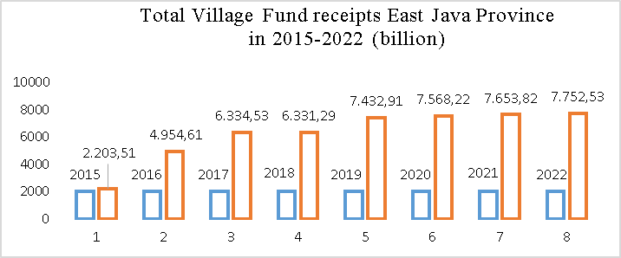

Source: Data processed from DJPK Ministry of Finance, 2023

To increase regional self-sufficiency, the regional government seeks to upgrade local income (PAD) to finance regional enhancement. The amount of PAD is an indicator of the independence of a region. In Figure 2 it can be seen that the PAD in 30 Districts/Cities receiving Village Funds in East Java for 2015-2022 shows an increasing trend. However, in 2022 it will decrease. Village Funds and PAD are the main sources of financing for regional development and poverty alleviation.
The State of Indonesia has ratified the global Sustainable Development Goals (SDGs) into the National SDGs through Presidential Decree 59/2017 concerning Aapplication of Attainment SDGs. In Presidential Decree number 59/2017 it is explained that “SDGs are documents that contain global goals and targets for 2016 to 2030”. “At the national and regional levels, poverty has become a complex and chronic problem, so an appropriate and sustainable strategy is needed to overcome it”.
Figure 2: Total PAD in 30 Districts/Cities Recipient of Village Funds
In East Java Year 2015-2022
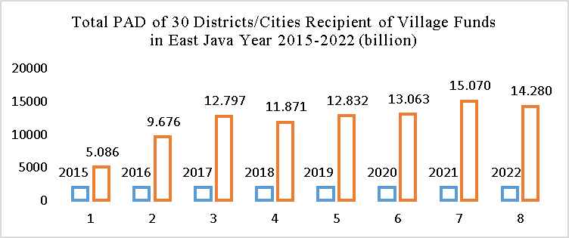

Source: Data processed from DJPK Ministry of Finance, 2023

If the Village Fund is managed properly and correctly, it will be able to increase the community's economic growth. Economic growth should be able to help alleviate poverty because more goods and services are produced by productive economic activities.
Agency theory is “a contract between Principals who employ Agents to achieve a goal. Every when one party (principal) employs another party (agent) to perform certain services and delegate power decision making to the agent, the agency relationship exists”. Local and village government as agents are expected to be able to work optimally in achieving prosperity and poverty alleviation.
The granting of authority to an autonomous region is further expanded with the existence of Law 6 of 2014 about Villages which contains the granting of dominion to villages to manage and develop their territory in appropriate with local traditions and customs while still being guided by statutory regulations. Managing, maintain and building the government provides funds to the village which is named the Village Fund.
“Village Funds are funds sourced from the State Revenue and Expenditure Budget intended for villages that are transferred through the Regency/City Regional Revenue and Expenditure Budget and are used to finance government administration, implementation of development, coaching, community and empowerment, public”.
“Local Government Revenue (PAD) is income earned by the region which is collected based on regional regulations in accordance with statutory regulations”. Economic Growth Sources of PAD according to Law Number 28 of 2009 consist of “Regional Taxes, Regional Levies, Results of Separated Regional Wealth Management, and Other Legal PAD”. Regional autonomy requires that each region is able to explore the maximum potential of PAD to eliminate dependence on funding from the central government.
“Economic growth is one of the indicators used as a benchmark; the success of development of an area of economic growth in East Java has increased and decreased”. The Central Bureau of Statistics (BPS) uses constant (real) price GRDP data to display the level of economic step-up as a aggregate or for each area from year to year. GRDP at constant prices explains the added worth of these goods and services which is counted exerting rates apply in a certain year as the fundamental year.
BPS uses the concept of capability to fulfill basic needs (basic needs oncoming) to gauge poverty. This design takes part to the Handbook on Poverty and Inequality launched by the World Bank. “With this approach, poverty is seen as an economic inability to meet basic food and non-food needs as measured from the expenditure side. Residents are categorized as poor if they have an average expenditure per capita per month below the poverty line”. In Figure 3 it able to seen that the number of poor people in East Java shows a not very significant downward trend.
Figure 3: Number of poor people in districts and city receiving Village Funds in East Java Province in 2015-2022
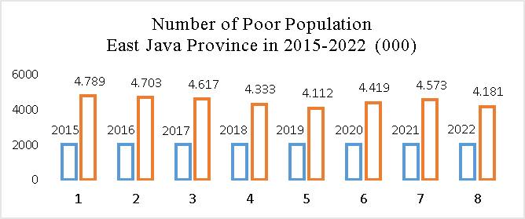

Source: BPS East Java, 2023
Source: BPS East Java

The World Bank in its latest report changed the poverty line standard which refers to the 2017 purchasing power parities (PPP) rules, replacing the 2011 PPP. This is because the World Bank sees an increase in the poverty line in various countries. With these changes, the World Bank set the extreme poverty line to be US$ 2.15 or the equivalent of Rp.32,757.4 (with a reference rate of Rp.15,236 per US dollar) per person per day in the 2017 PPP. This standard has increased compared to the 2011 PPP, which was Rp. US$ 1.9 or IDR 28,984.4 per person per day.
Previous research stated that village funds had a negative and significant effect on the poverty rate. Allocation of village funds has a significant impact on poverty. This is meaningful; the Village Fund is able to decrease the level or sum of poor people. In another study in Pesisir Selatan District, it was shown that there was no significant connection range Village Funds and a decrease in poor families or an enhancement in the amount of village funds was not accompanied by a reduction in the poverty rate.
Village funds need to be managed properly to get maximum results for community economic empowerment and poverty alleviation. There is a good example of Village Fund management in Potorono village, Banguntapan District, Bantul Regency, Yogyakarta. “The management of Potorono village funds for community satisfaction has been carried out properly and effectively, it has increased community welfare, equitable distribution of productive development such as human resource development, counseling for the community, and building a new culture from a mindset that is still traditional to tourism-aware groups, such as the Potorono’s lake, Balong’s Water Park”.
If the Village Fund is managed properly and correctly, it will be able to increase the community's economic growth. PAD has a positive and significant influence on economic accretion . In other study, Original Income does not have a significant impact on economic accretion.
Various studies on economic growth show that economic growth has a negative and significant influence on poverty in the districts and city of West Sumatra. The outputs of other research exhibit that economic accretion has no significant influence on poverty levels. Economic growth should be able to contribute to alleviating poverty because more goods and services are produced by productive economic activities.

RESEARCH METHOD
This model of study is quantitative with an explanatory oncoming. The type of research sample was purposive sampling in all regencies (29 regencies) and cities (1 Batu City) in East Java province in 2015–2022. Village Fund implementation began in 2015. Secondary data on Village Funds and Local Government Revenue were available of DJPK situs. Secondary data on poverty by proxy for the number of poor people (JPM) and economic growth by proxy for constant price Gross Regional Domestic Product (GRDP) from BPS.
Based on the background, research hypotheses can be formulated:
H1: Village funds have an influence on poverty in regencies and city in East Java.
H2: Village funds have an influence on economic accretion in regencies and city in East Java.
H3: PAD has an impact on poverty in regencies and city in East Java.
H4: PAD has an impact on economic accretion in regencies and city in East Java.
H5: Economic accretion has an influence on poverty in regencies and city in East Java.
H6: Village funds have an indirect influence on poverty through economic accretion in regencies and city in East Java.
H7: PAD has an indirect impact on poverty through economic accretion in regencies and city in East Java.
An explanation of the hypothesis shown in Figure 4.
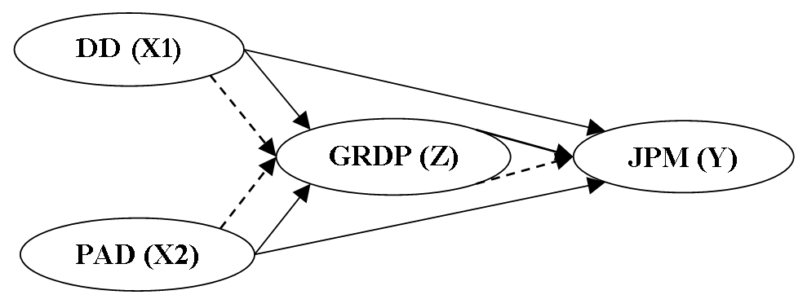

Figure 4. Conceptual Framework
Annotation:
Village Fund: DD. Original Government Revenue: PAD. Economic Accretion (Gross Regional Domestic Product): GRDP. Poverty: JPM
The research model equation is as follows:
- Direct equation
- Village Funds (X1), PAD (X2) and Economic Growth (Z) on Poverty (Y) →Y = X1 + X2 + Z + ε1
- Village Funds (X1) and PAD (X2) on Economic Growth (Z)
→ Z = X1 + X2 + ε2
- Indirect influence of Village Funds (X1) and PAD (X2) on Poverty (Y) which is mediated by Economic Growth (Z) → Y = bX1*Z + bX2*Z + ε
Steps for testing statistical data
The data processing method uses path analysis with the SmartPLS 3 tool. A natural logarithm process is carried out on the Village Fund Data, PAD, GRDP, and the amount of destitute people. The study model is shown in Figure 4. “Q-Square can measure how well the observed values produced by the model and also the parameter estimates”. “A Q-Square value greater than 0 (zero) indicates that the model has a predictive relevance value. Meanwhile, if the Q-Square value is less than 0 (zero), then the model has less or no predictive relevance”. “Predictive value – relevance is obtained by the formula: Q² = 1 – (1 – R1²) (1 – R2²) …. (1 – Rn²)”. Furthermore, direct and indirect (mediation) hypothesis testing was carried out. If the significant grade ≤ 0.05 that is to say that variable X has an influence on Y and has a significant influence if t Statistics > t Table.
RESULT AND DISCUSSION
Research Result
1. Q Square Testing
Q² =1–(1– R1²)(1–R2²)
Q² =1–(1–0.606)(1–0.452)
Q² = 0.485
R² value can be seen at figure 5 in variable Y (JPM/poverty) and Z (GRDP). The outputs of the Q-Square calculation in its research amounted to 0.485 or 48.5%, that is to say that the study model has a relevant predictive score. The model used means the clue contained in the data study by 48.5%.
2. Testing Direct Effects
The outputs of the direct effect test able to read in table 1.
Table 1. Results of Hypothesis-testing (Direct Effect)
Hyp. | Relationship | Coefficient | T Statistics | P-value | Conclusion
H1 | DD→JPM | 0,820 | 11,802 | 0,000 | Significant
H2 | DD→GRDP | 0,089 | 1,820 | 0,069 | Not Sig.
H3 | PAD→JPM | -0,565 | 7,715 | 0,000 | Significant
H4 | PAD→GRDP | 0,614 | 8,586 | 0,000 | Significant
H5 | GRDP→JPM | 0,426 | 6,718 | 0,000 | Significant
Source: Smart PLS Outputs, 2023
H1: Village funds have a significant positive influence on poverty in regencies with city in East Java in 2015 - 2022 with a statistical t number of 11.802 (> t table 1.970) and a P-number of 0.000 <0.05 so hypothesis 1 is approved. The coefficient number of 0.820 can be interpreted, if the Village Fund increases by one unit, poverty (JPM) will have an effect of 0.820.
H2: Village funds have no significant positive influence on economic increasing in regencies and city in East Java in 2015 - 2022 with a statistical t mark of 1.820 (> t table 1.970) with a P-mark of 0.069 > 0.000 so hypothesis 2 is rejected. The coefficient number of 0.089 can be interpreted, if the Village Fund mount by one unit, welfare will increase by 0.089.
H3: PAD has a significant negative influence on poverty in regencies and city in East Java in 2015 - 2022 with a statistical t mark of 7,715 (> t table 1,970) and a P-number of 0.000 <0.05 so hypothesis 1 is approved. The coefficient number of -0.565 can be interpreted, if PAD grow up by one unit, then poverty will decrease by -0.565.
H4: PAD has a significant positive influence on economic accretion in regencies and city in East Java in 2015 - 2022 with a statistical t number of 8.586 (> t table 1.970) and a P-number of 0.000 <0.05 so hypothesis 4 is approval. The coefficient number of 0.614 can be interpreted, if PAD grow up by one unit, economic accretion will go up by 0.614.
H5: Economic accretion has a significant positive influence on poorness in districts in East Java in 2015 – 2022, a statistical t number of 6.718 (> t table 1,970) and a P-number of 0.000 <0.05 and Hypothesis 5 is approval. The coefficient number of 0.426 can be interpreted, if economic growth increases by one unit, welfare increases by 0.426.
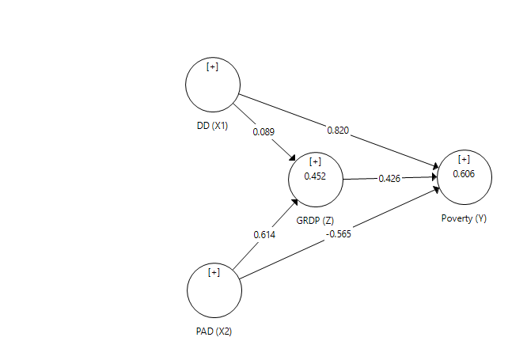
The ability to influence each exogenous variable on endogenous variables can be seen in Figure 5.

Source: Smart PLS Outputs

Figure 5: Research Model Relationship (coefficient)
3. Testing Indirect Effects
The indirect effect of the research results able to read in table 2.
Table 2. Outputs of Hypothesis-testing (Indirect Effects)
Hyp. | Relationship | Co. | T Statistics | P-value | Conclusion
H6 | DD→GRDP→JPM | 0,038 | 1,997 | 0,046 | Significant
H7 | PAD→GRDP→JPM | 0,262 | 4,161 | 0,000 | Significant
Source: Smart PLS Outputs
H6: Village Funds have an indirect positive influence on poverty (JPM) via economic accretion in regencies and cities in East Java in 2015-2022 due to a significant value of 0.046 > 0.05 with a t statistic of 1.997 (> t table 1.970) and the hypothesis 6 is accepted. From the coefficient number of 0.038 it can be interpreted if the Village Fund go up by one unit, then poverty will have a positive effect indirectly through economic growth of 0.038.
H7: PAD has an indirect positive effect on poverty (JPM) via economic accretion in regencies/cities in East Java in 2015-2022 due to a P-number of 0.000 > 0.05 with t statistic of 4.161 (> t table 1.970) so that Hypothesis 7 is accepted. From the coefficient value of 0.262 it can be interpreted if PAD go up by one unit, then poverty (JPM) will have a positive effect indirectly through economic growth of 0.262.
The impact of Village Funds on poverty
The outcomes of the study are Village Funds have a positive influence on Poverty in districts in East Java in 2015 – 2022. Village Funds have a positive influence on poverty alleviation. The purpose of village funds is to alleviate poverty. Availability of village funds is a manifestation of satisfying village rights to implement its autonomy and it arises and thrives. The task of the village government in supply services and improving community prosperity must continue to be encouraged. With the attendance of the Village Fund, it is hoped that it can accelerate the process of regional development as a whole so that it can reduce development disparities between regions and between villages. The village government has strategic circumstances in creating justice in the distribution of project.
The outcomes of the current study are in suitable with the precursor studies but in a different direction of the coefficient values. Village funds have a negative and significant influence on the poorness rate . Allocation of village funds has a significant impact on poverty. However, the outcomes of this research are in contrast to the results of study in Pesisir Selatan District which shows that there is no significant connection among Village Funds and a decrease in needy families or a go on in the amount of village funds is not followed by a reduction in the poorness level.

The Impact of Village Funds on Economic Growth
The outputs of the current research are Village Funds do not have a significant positive influence on economic accretion in regencies and city in East Java in 2015 – 2022. The effect of the Covid-19 pandemic in 2020 – 2021 has been so great on the economy in East Java. The economy of the East Java region has stagnated and the utilization of village funds has been more focused on programs for mitigating the impact of Covid-19. At that time, the community had difficulty developing their economy due to various restrictions on social activities. People find it difficult to work and earn income. Furthermore, after the pandemic, the community restarted their economic activities.
The outputs of the present research are the Village Fund has no significant influence on economic growth. This is because East Java experienced a severe covid-19 pandemic in 2020 – 2021. Even after that, the people's economy has not recovered. The current research results contradict the research conclusions; the implementation of village funds has a positive and significant effect on economic accretion in Indonesia. This is because the research data was obtained before the Covid-19 pandemic.
The Effect of PAD on Poverty
The outputs of the current research are PAD has a significant negative influence on poorness. That is, an enhancement in the amount of PAD causes the poverty rate to decrease. PAD is extracted from local regional taxes and fees to finance local government operations and development. The amount of PAD shows the independence of a region. Local governments need to optimize the use of PAD for poverty alleviation programs. The outputs of the current research are slightly contrasted from study; Regional Original Revenue does not have a significant influence on Economic Accretion in Papua Province.
The Influence of PAD on Economic Growth
PAD has a positive and significant influence on economic accretion in regencies and city in East Java. PAD is the ability of the Regional Government to explore potential revenues originating from the region. The amount of PAD reflects the economic condition of a region. The generated PAD needs to be rotated again and managed properly and correctly, so that it can increase the community's economic growth.
The current research outputs are in suitable with the study conclusions but the coefficient is positive, namely PAD has a positive and significant influence on economic accretion . Other research shows the opposite, Local Own Revenue does not have a significant impact on Economic Growth.
The Effect of Economic Accretion on Poorness
The results of the present research show that economic accretion has a significant positive impact on poverty. Economic accretion as a positive result of development can alleviate poverty. Therefore, economic development through increasing GRDP must continue to be improved to encourage the prosperous of public as a whole. Various studies on economic accretion show that economic growth has a negative and significant impact on poorness in the districts/city of West Sumatra. The outputs of other research produce economic accretion have no significant influence on the poverty rate .
The influence of Village Funds on poverty through economic accretion
The outputs of the current study are the Village Fund has an indirect and significant positive influence on poverty via economic accretion (GRDP) in districts in East Java in 2015 – 2022. The Village Fund Program has been able to show positive performance in poverty alleviation. But it needs to be a joint evaluation to increase the effectiveness of using village funds in economic growth.
The government has committed to implementing SDGs or Sustainable Development Goals (TPB). SDGs in Indonesia are aligned with the implementation of Law 6 of 2014 about Villages. The SDGs program is implemented at the Village SDGs level. The existence of the Village Fund is a serious effort by the government in accelerating development in the form of community empowerment, poverty alleviation and increasing community welfare. Village funds need to be continuously improved in quality so that they have a more positive impact on village development.
The impact of PAD on poverty through economic accretion
The outputs of the research show that PAD has a significant positive impact indirectly on poverty through economic accretion in regencies and city in East Java in 2015 – 2022. PAD as an indicator of regional independence has been able to contribute to alleviating poverty and encouraging economic accretion in regencies and city in East Java. Poverty alleviation and economic accretion are interrelated work programs. The results of PAD must be encouraged to increase economic growth. Through good economic growth it is hoped that it can contribute to alleviating poverty through the opening of new jobs.
CONCLUSION
Conclusion
Village Funds have a significant positive influence on poverty. The existence of the Covid-19 pandemic has greatly influenced the increase in the poorness rate in districts/cities receiving Village Funds in East Java. Village Funds have no significant impact on economic accretion. The Village Fund is focused on dealing with the influence of the pandemic rather than on driving economic accretion.
PAD has a significant negative influence on poorness. It can be interpreted that the results of PAD are prioritized on regional expenditure allocations in general rather than poverty alleviation programs. PAD has a significant positive influence on economic accretion. The use of PAD has been able to push regional economic accretion. Economic accretion has a significant positive effect on poverty. With the growing of the regional economy, it will have an influence on employment or unemployment, so that the poor population can be reduced.
Village Funds have a significant positive indirect influence on poverty via economic growth. PAD has a significant positive indirect influence on poverty through economic accretion. Economic growth is a trigger for Village Funds and PAD in poverty alleviation.
Implication
The local government is expected to continue to optimize the village fund program for poverty alleviation and improving the community's economy. With village funds, expected impact of co-19 pandemic will be able to recover more quickly from the economic downturn. The government should increase supervision and guidance on the use of village funds so they are more effective and efficient in encouraging the attainment of SDGs. The role of village fund assistants needs to be optimized not only limited to assisting with administrative correctness, but also directed at achieving village vision-mission targets. Regional independence through increasing PAD must continue to be pursued in the framework of enhancement the welfare of the community as a whole.
Research Limitations
The research period is relatively short, namely 2015 – 2022. Moreover, in 2020 – 2021 the East Java province experienced a pandemic and afterwards was still recovering from the co-19 pandemic. So this is very influential on the economic activity of the community. Suggestions for subsequent research are to extend the research time and take research themes by comparing the implementation of Village Funds and PAD on economic accretion and poverty before and after the Covid-19 pandemic.■

REFERENCES
Books
Chin, W. W. The Partial Least Squares Aproach to Structural Equation Modeling. Modern Methods for Business Research, (1998), 295, 336.
Ghozali, Imam. Application of Multivariete Analysis with the IBM SPSS 23 Program. Edition 8 (2016). Semarang: Diponegoro University Publishing Agency.
Hair, Jr., Joseph F., et. al. Multivariate Data Analysis. Fifth Edition (2011). New Jersey: Prentice Hall, Inc.
Sagara, Yusar. Sistem Pengendalian Manajemen. Ed. 1, Cet. 1. (2021). Depok: Rajawali Pers.https://repository.uinjkt.ac.id/dspace/bitstream/123456789/61220/1/21.%20Buku%20Referensi%20Sistem%20Pengendalian%20Manajemen.pdf
Articles
Abdullah, R. The Influence of Village Funds on Poverty Levels in Gorontalo. Jambura Economic Education Journal, 4(2), (2022), 165-176.https://ejurnal.ung.ac.id/index.php/jej/index
Alisha, Wyanet Putri and Yulhendri. The Effect of Economic Growth on Poverty Levels in Districts/Cities of West Sumatra. Ecogen Journal, 4(4), . (2021), 581-593. DOI: http://dx.doi.org/10.24036/jmpe.v4i4.12455
Arfiansyah, Mufti Arief. The Impact of Village Funds in Poverty Reduction in Central Java. Lisyabab Journal of Islamic and Social Studies, 1(1), (2020). 91-106. DOI: https://doi.org/10.58326/jurnallisyabab.v1i1.20
Bukhari, Erin. The Influence of Village Funds in Alleviating Poverty of Villagers. Journal of Scientific Studies, 21(2), (2021), 219 – 228. DOI: https://doi.org/10.31599/jki.v21i2.540
Dewi, Ratna Sari and Irama, Ova Novi. The Influence of ADD on Poverty: A Case Study in North Sumatra Province. Journal of Accounting and Business, 4(2), (2018), 11-18. DOI: 10.31289/jab.v4i2.1513
Dini, Siti; Tarigan, Eva Agustina Br.; Siregar, Melva Nava Abeliana. The Influence PAD, DAU, DAK, and Capital Expenditure to Economics Growth in Aceh Province. Pareto : Jurnal Ekonomi dan Kebijakan Publik. 4(2), (2021). 65-80. DOI: 10.32663/pareto.v4i2.1831
Gusti, Yenni; Agustar, Asdi dan Osmet. Utilization of Village Funds and its relation to poverty alleviation in the Pesisir Selatan district. JIMEA Jurnal Ilmiah MEA (Manajemen, Ekonomi, dan Akuntansi), 4(2), (2020). DOI: https://doi.org/10.31955/mea.v4i2.379
Margareni, Ni Putu Ayu Purnama; Djayastra, I Ketut; and Yasa, I.G.W Murjana. Factors Affecting Poverty in East Java Province. The Pyramids, XII(1), (2016). 101-110. https://ojs.unud.ac.id/index.php/piramida/article/view/30180
Panggabean, Helena Louise; Hariani, Danarti: and Yanuar B, A. The Effect of General Allocation Funds, Regional Original Income and Special Allocation Funds on Poverty with Economic Growth as Intervening Variables in 2015-2019. Owner: Accounting Research & Journal, 6(2), (2022), 2200-2208. DOI : https://doi.org/10.33395/owner.v6i2.836
Pradana, Asika Cahyaning Tiwi and Mun'im, Akhmad. The Effect of Local Revenue and Balancing Funds on the Economy of Bali Province in 2012–2019. Bina Praja Journal. 14(3), (2022), 439–451. DOI: https://doi.org/10.21787/jbp.14.2022.439-451
Putri, Rosidatul Halim Najib and Yuliana, Indah. The effect of economic growth on the level of poverty with unemployment as mediation in Probolinggo. Fair Value : Scientific Journal of Accounting and Finance, 5(6), (2023), 2691-2700. DOI: https://doi.org/10.32670/fairvalue.v5i6.2531
Rofii, Andrik Mukamad and Ardyan, Putu Sarda. (2017). Analysis of the Influence of Inflation, Foreign Investment and Labor on Economic Growth in East Java. Journal of Economics & Business, 2(1), 303 – 316.
Saguin, Kidjie. Why The Poor Do Not Benefit: Lesson From The Participatory Budgeting. World Development, 112, (2018), 220–232. https://doi.org/10.1016/j.worlddev.2018.08.009
Shofiyanti, Erwin. Potorono Village Fund Management on Community Satisfaction in the View of Islamic Economics. Al-Falah Journal of Islamic Economics. 6(1),(2021),71-84. DOI: 10.29240/alfalah.v6i1.2596
Sunu, Made Krisna Kalpika and Utama, Made Suyana. The influence of Village Funds on the level of poverty and community welfare in the districts/cities of the province of Bali. E-Journal of Economics and Business, Udayana University, 8(8), (2019). 843-872.
Wambemu, Kristina T; Rotinsulu, Tri Oldy; and Naukoko, Amran T. The Effect of Economic Growth on Employment Opportunities and poverty rates in Merauke district. Efficiency scientific periodical journal. 22(7), (2022), 1-12.
Yunas, Ismi Nabilla and Siregar, Muhammad Ilhamsyah. The effect of the realization of village funds on economic growth in Indonesia. Student Scientific Journal (JIM) Development Economics Faculty of Economics and Business Unsyiah, 4(4), (2019), 337-348. https://jim.usk.ac.id/EKP/article/view/14948
Zatadini, Nabila and Syamsuri. The Concept of Maqashid Sharia According to Al-Syatibi and Its Contribution to Fiscal Policy. Al Falah: Journal of Islamic Economics, 3(2), (2018), 111-124.
DOI: http://dx.doi.org/10.29240/alfalah.v3i2.587
Regulations
Law (UU) Number 28 of 2009 concerning Regional Taxes and Regional Levies
Law (UU) Number 33 of 2004 concerning Financial Balance between the Center and the Regions
Law (UU) Number 6 of 2014 concerning Villages
Regulation of the Minister of Home Affairs (Permendagri) Number 113 of 2014 concerning Village Financial Management
Presidential Decree (Peraturan Presiden) Number 59 of 2017 Concerning the Implementation of the Achievement of Sustainable Development Goals (SDG's)
Internet Sources
https://djpk.kemenkeu.go.id/portal/data/apbd (accessed 04-14/04/2023)
https://jatim.bps.go.id/ : Number of poor people in districts/cities receiving Village Funds in East Java Province in 2015-2022 (accessed 15-25/04/2023)
https://bisnis.tempo.co/read/1640478/bank-dunia-revisi-standar-garis-kemiskinan-dtks-di-indonesia-akan-berubah (accessed 17/05/2023)
https://www.bps.go.id/subject/23/kemiskinan-dan-ketimpangan.html (accessed 19/05/2023)

Zatadini Nabila and Syamsuri. The Concept of Maqashid Sharia According to Al-Syatibi and Its Contribution to Fiscal Policy. Al Falah: Journal of Islamic Economics, 3(2), (2018), 111-124.
Kidjie Saguin. Why The Poor Do Not Benefit: Lesson From The Participatory Budgeting. World Development, 112, (2018), 220–232.
Margareni, Ni Putu Ayu Purnama; Djayastra, I Ketut; and Yasa, I.G.W Murjana. Factors Affecting Poverty in East Java Province. The Pyramids, XII(1), (2016). 101-110.
Sagara, Yusar. Sistem Pengendalian Manajemen. Ed. 1, Cet. 1. (2021 : 147). Depok: Rajawali Pers.
Regulation of the Minister of Home Affairs (Permendagri) Number 113 of 2014 concerning Village Financial Management
Law (UU) Number 33 of 2004 concerning Financial Balance between the Center and the Regions
Law (UU) Number 28 of 2009 concerning Regional Taxes and Regional Levies
Rofii, Andrik Mukamad and Ardyan, Putu Sarda. (2017). Analysis of the Influence of Inflation, Foreign Investment and Labor on Economic Growth in East Java. Journal of Economics & Business, 2(1), 303 – 316.
https://www.bps.go.id : Number of poor people in districts/cities receiving Village Funds in East Java Province in 2015-2022
Ibid
https://bisnis.tempo.co/read/1640478/bank-dunia-revisi-standar-garis-kemiskinan-dtks-di-indonesia-akan-berubah
Made Krisna Kalpika Sunu and Made Suyana Utama. The influence of Village Funds on the level of poverty and community welfare in the districts/cities of the province of Bali. E-Journal of Economics and Business, Udayana University, 8(8), (2019), 843-872.
Mufti Arief Arfiansyah. The Impact of Village Funds in Poverty Reduction in Central Java. Lisyabab Journal of Islamic and Social Studies, 1(1), (2020), 91-106.
Erin Bukhari. The Influence of Village Funds in Alleviating Poverty of Villagers. Journal of Scientific Studies, 21(2), (2021), 219 – 228.
R. Abdullah. The Influence of Village Funds on Poverty Levels in Gorontalo. Jambura Economic Education Journal, 4(2), (2022), 165-176.https://ejurnal.ung.ac.id/index.php/jej/index
Ratna Sari Dewi and Ova Novi Irama. The Influence of ADD on Poverty: A Case Study in North Sumatra Province. Journal of Accounting and Business, 4(2), (2018), 11-18.
Yenni Gusti, Asdi Agustar, and Osmet. Utilization of Village Funds and its relation to poverty alleviation in the Pesisir Selatan district. JIMEA Jurnal Ilmiah MEA (Manajemen, Ekonomi, dan Akuntansi), 4(2), (2020).
Erwin Shofiyanti. Potorono Village Fund Management on Community Satisfaction in the View of Islamic Economics. Al-Falah Journal of Islamic Economics. 6(1), (2021), 71-84.
Siti Dini, Eva Agustina Br. Tarigan, Melva Nava Abeliana Siregar. The Influence PAD, DAU, DAK, dan Capital Expenditure to Economics Growth in Aceh Province. Pareto: Jurnal Ekonomi dan Kebijakan Publik, 4(2), (2021).
Ismi Nabilla Yunas and Muhammad Ilhamsyah Siregar. The effect of the realization of village funds on economic growth in Indonesia. Student Scientific Journal (JIM) Development Economics Faculty of Economics and Business Unsyiah, 4(4), (2019), 337-348.
Asika Cahyaning Tiwi Pradana and Akhmad Mun'im. The Effect of Local Revenue and Balancing Funds on the Economy of Bali Province in 2012–2019. Bina Praja Journal. 14(3), (2022), 439–451.
Helena Louise Panggabean, Danarti Hariani and A. Yanuar B. The Effect of General Allocation Funds, Regional Original Income and Special Allocation Funds on Poverty with Economic Growth as Intervening Variables in 2015-2019. Owner: Accounting Research & Journal, 6(2), (2022), 2200-2208.
Wyanet Putri Alisha and Yulhendri. The Effect of Economic Growth on Poverty Levels in Districts/Cities of West Sumatra. Ecogen Journal, 4(4), . (2021), 581-593.
Rosidatul Halim Najib Putri and Indah Yuliana. The effect of economic growth on the level of poverty with unemployment as mediation in Probolinggo. Fair Value : Scientific Journal of Accounting and Finance, 5(6), (2023), 2691-2700.
Kristina T. Wambemu, Tri Oldy Rotinsulu, and Amran T. Naukoko. The Effect of Economic Growth on Employment Opportunities and poverty rates in Merauke district. Efficiency scientific periodical journal. 22(7), (2022), 1-12.
Imam Ghozali. Application of Multivariete Analysis with the IBM SPSS 23 Program. Edition 8 (2016). Semarang: Diponegoro University Publishing Agency.
Chin, W. W. The Partial Least Squares Aproach to Structural Equation Modeling. Modern Methods for Business Research, (1998), 295, 336.
Hair, Jr., Joseph F., et. al. Multivariate Data Analysis. Fifth Edition (2011). New Jersey: Prentice Hall, Inc.
Made Krisna Kalpika Sunu and Made Suyana Utama. (2019)
Mufti Arief Arfiansyah. (2021)
Erin Bukhari. (2021)
R. Abdullah. (2022)
Ratna Sari Dewi and Ova Novi Irama. (2018)
Yenni Gusti, Asdi Agustar, and Osmet. (2020)
Ismi Nabilla Yunas and Muhammad Ilhamsyah Siregar. (2019)
Helena Louise Panggabean, Danarti Hariani and A. Yanuar B. (2022)
Siti Dini, Eva Agustina Br. Tarigan, Melva Nava Abeliana Siregar. (2021)
Ismi Nabilla Yunas and Muhammad Ilhamsyah Siregar. (2019)
Asika Cahyaning Tiwi Pradana and Akhmad Mun'im. (2022)
Helena Louise Panggabean, Danarti Hariani and A. Yanuar B. (2022)
Wyanet Putri Alisha and Yulhendri. (2021)
Rosidatul Halim Najib Putri and Indah Yuliana. (2023)
Kristina T. Wambemu, Tri Oldy Rotinsulu, and Amran T. Naukoko. (2022)

